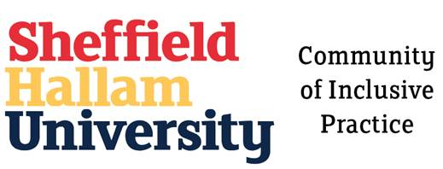

Community of Inclusive Practice
Hallam Guild - Themed Week - 24th June - 28th June 2019

Reflection on the week and next steps
Marissa Hill - Jo Fleming - Karl Townsend - Helen Heywood
Nick Russell - Natalie Brownell
This session gave the group an opportunity to reflect on the weeks activities and discuss next steps along with the raffle prize draw!
Winners of the raffle draw
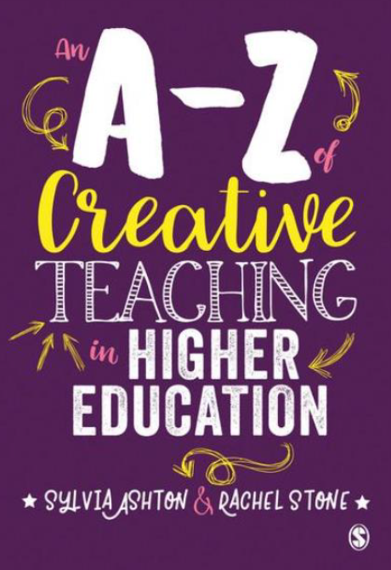
Well done to our raffle prize draw winners
- Nick Russell
- Richard Lynch

Hallam Guild Group - Community of Inclusive Practice
The Hallam Guild Group was a 2 year proposal and following the first themed week it was felt that a repeat of the workshops and activates would be most welcome from the community. The group will review all feedback and outcomes from this event and develop a calendar of events for the Community of Inclusive Practice members and open up to the wider Hallam community including Students Union. The group will also be represented at various Faculty and Departmental events to raise the profile of the group, such as Course Leader events, Faculty LTA conferences etc.
Action:
- develop calendar of events and advertise in the new academic year 2019/20
- set-up regular meetings for the group to discuss on-going work and projects and review membership contributions

Next steps
Here are some the points raised and thoughts of the group:
- the need to promote the Spaces for Learning resources
  - linking in with considerations on how space is used in inclusive teaching
  - contacting Liz Dickins FD to see if estates planning considers accessibility/inclusivity as the norm
- Review 'disabled Go' site - is it up to date? How many site hits? Is it a 'go to' resource?
- Campus maps - there is an ongoing project (Lucy Davies) looking at how accessible our campus maps are and are they fit for purposes?
- My Hallam - is the site accessible? Who is responsible for the content/update of this resource? Action: Natalie to speak with Claire Ward, lead on My Hallam
- Make links with health and wellbeing groups via Heads of Service
- Hallam Model - is accessibility and inclusivity embedded in this new model? Action: Natalie to speak with Elaine Buckley, lead on Hallam Model
- Hallam Welcome - is a resource currently being developed (Sarah Smart and Natalie Brownell) - consider:
  - Student inductions - code of conduct for all our students - where/who/what?
  - Staff inductions - HR used to run a monthly staff induction event whereby new staff would receive information and a chance to meet various colleagues in different areas providing staff services, such as unions, academic development etc. These are no longer run but is there a need for them still? Also to incorporate
    - Accessibility - code of conduct for staff - where/who/what?
    - Inclusive Practice - you will…….we will…….. - statement
- Quality Assurance - how accessibility and inclusivity are embedded in our quality assurance processes
  - Quality Assurance - Leopold Green Action: Natalie to review and gather evidence
  - SAS are currently applying for a 'customer service excellence' mark - Denise Nelson is leading this
- DSA steering group - currently reviewing policies on
  - video/audio recordings in lectures
  - EU directive which is to take effect from September 2019 - who/what/where? Need to find out which Hallam ULT board this will be discussed at. It is on the Provost Group strategic planning Action: Natalie to ask Claire Ward (lead on project)

