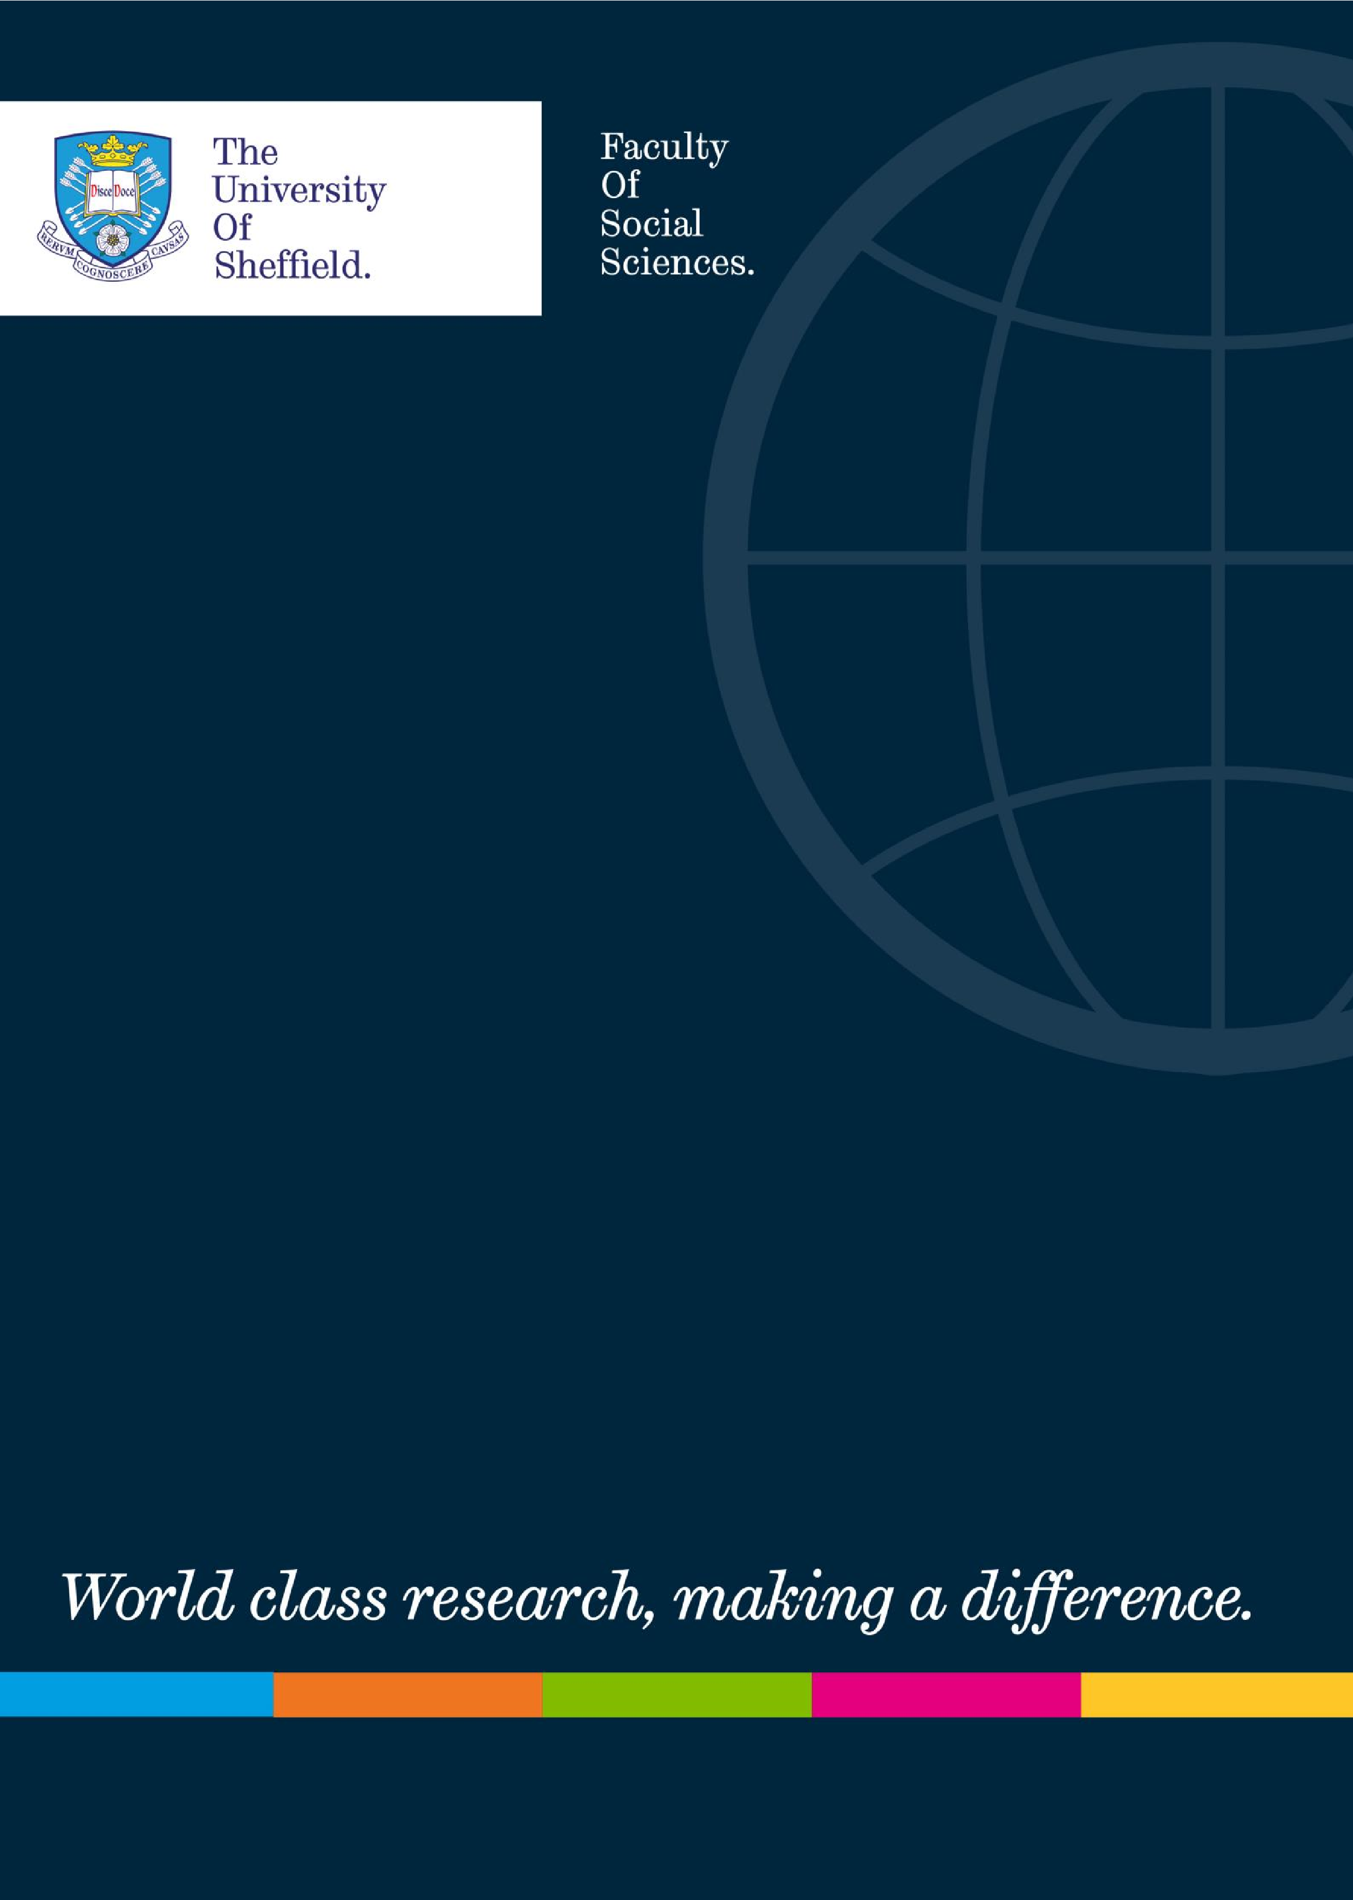

**“Trade Union Activism within a Pandemic”**

**Dr. Charmaine Blaize (UNISON) Tuesday 8 December 1 – 2pm**

<https://eu.bbcollab.com/guest/422e56e655e646dfb3416c1ae71e6b52>

By its very nature, disability is often difficult to define. This may be due to how we view it from a social or medical model – or in the sense that it might either be transient or permanent and therefore impact differently on each individual.

In this session, our guest Charmaine Blaize will reflect on her own experience of disability drawing on personal experience – and linking this to a discussion of how trade union activism can help to agitate and promote a fairer workplace and society for all; particularly persons with disabilities. She will also explore some of the potential challenges that have been presented as a result of the COVID-19 pandemic.

Dr Charmaine Blaize works in healthcare, NHS Scotland and is actively involved with one of the largest trade unions in the UK, UNISON. Her experiences of living with and supporting persons with disabilities and/or affected by disabilities has made her keen to advocate for equalities as there are issues such as stigma, discrimination, inequality and representativeness that needs to remain on the agenda.