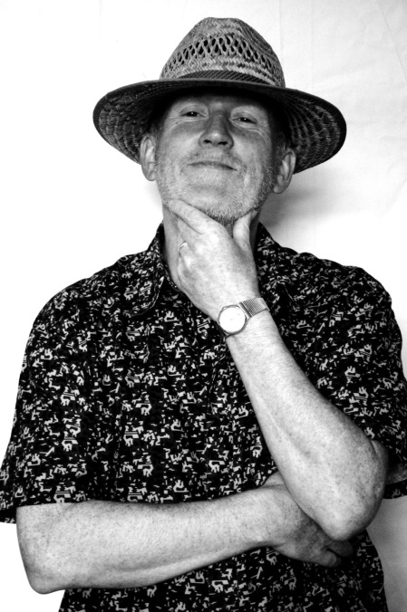
Academic Development & Diversity Team

Paddy Turner
Tel: ext. 4491
Email: p.turner@shu.ac.uk
Paddy has worked for SHU for over 20years and has at all times retained a passion for improving access
to and inclusion in, the academic and cultural environment. Initially working in Disabled Student Support
supporting students as a degree level BSL Interpreter, developing and managing services and working
to enhance inclusive teaching practice, he secured the PGCert in Learning and Teaching in HE in 2005,
became Head of Inclusive Practice (Disability) in 2008 before taking the inclusive practice remit into an
academic SL education development role in 2011.
He achieved Senior Fellowship of the HEA (now Advance HE) in 2015 and now takes the leading role in supporting the TALENT Framework for Professional Recognition. Before time began, Paddy graduated from the Royal Central School of Speech and Drama and subsequently worked for ten years as a professional actor. He now runs CPD workshops for staff in using your voice and presenting with confidence.
In addition to his work at SHU, Paddy has a national profile as a Director of the National Association of Disability Practitioners (NADP) including acting as Chair for 6yrs. NADP is a respected membership organisation with some 1500 members from all major UK universities and which, alongside supporting the development of disability practitioners and services nationally, also engages with and advises the OfS, the OIA, Government, SLC and other sector stakeholder groups influencing decision-making and policy.
This combination and breadth of experience has lead to invitations to run numerous workshops, give Keynote speeches and chair events on the development of inclusive practices both nationally and internationally.
Meet the team

