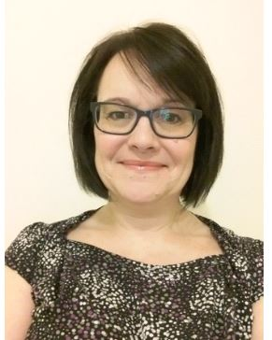
Academic Development & Diversity Team

Julie Smith
Tel: ext. 2838
Email: julie.smith@shu.ac.uk

Julie primarily manages the operational delivery of the university’s TALENT scheme, covering
HEA fellowship, National Teaching Fellowships and the Collaborative Award for Teaching Excellence
She is also the operational contact for the Hallam Guild.
As part of the wider Academic Development and Diversity team, Julie also supports work on communications, staff engagement, budget monitoring and academic resources. She has worked at Sheffield Hallam for over 20 years in various roles across a number of directorates, and has extensive experience in events management and business support.
During her career she has been responsible for the delivery of events such as graduation, the university's inspirational teaching awards and one of the first staff wellbeing programmes to be run at Sheffield Hallam.
Meet the team

