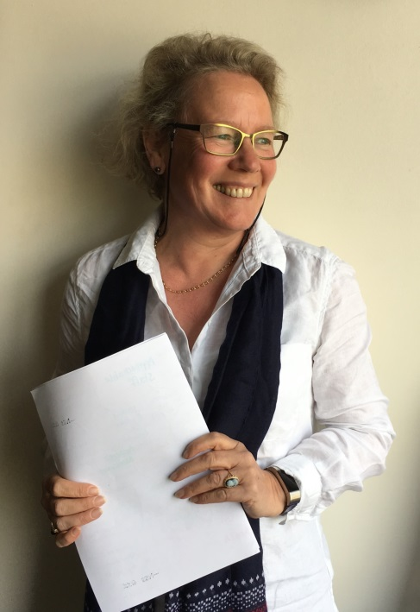
Academic Development & Diversity Team

Helen Kay
Tel: ext. 3705
Email: helen.kay@shu.ac.uk

Helen has a breadth of experience in pedagogic development and educational change.
Drawing on over thirty years of experience of teaching, curriculum development, course leadership
and institutional research her work supports academic and curriculum innovation and leadership.
Helen's practice is research informed and underpinned by a wealth of experience in evaluating the implementation of educational practices and providing an understanding of how students engage with and experience teaching and learning.
Helen has had a pivotal role in the development of equality and diversity and widening participation policy and strategy at Sheffield Hallam. She continues to lead on the development and implementation of inclusive teaching and learning policy and practice.
Helen completed her first degree in Geology at Oxford Polytechnic and initially worked in research and development in the steel casting industry. She subsequently joined the Super Clean Steel Research Group at Sheffield City Polytechnic and obtained a PhD in Chemical Metallurgy in 1996. She is a Senior Fellow of the Higher Education Academy.
Meet the team

