Finding a Student's Academic Adviser on SITS Online

1. From the staff.shu.ac.uk homepage select SITS Online;
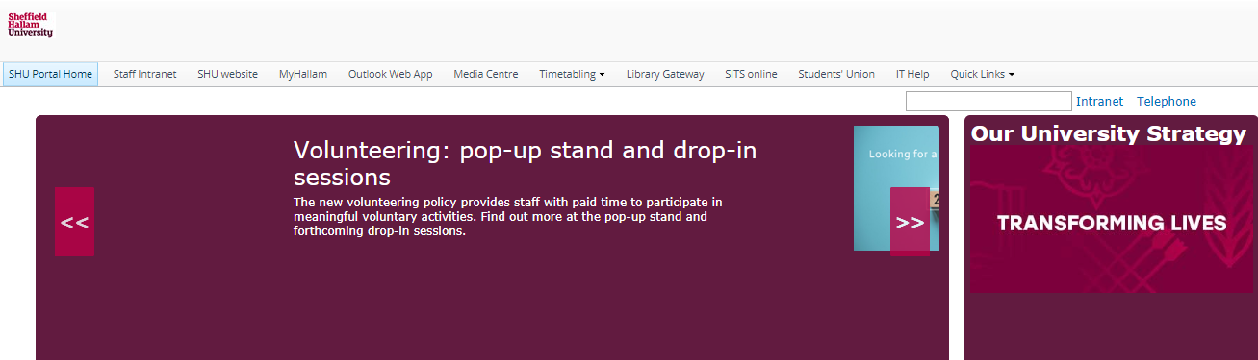
2. Log in and select Student View;
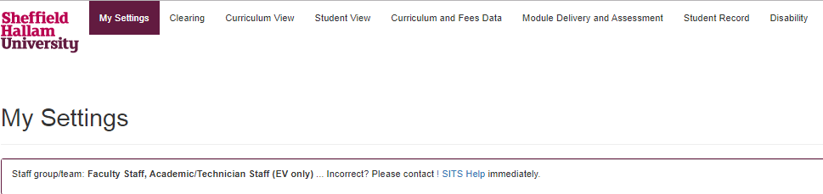

3. Click Go to Student View Search Page button;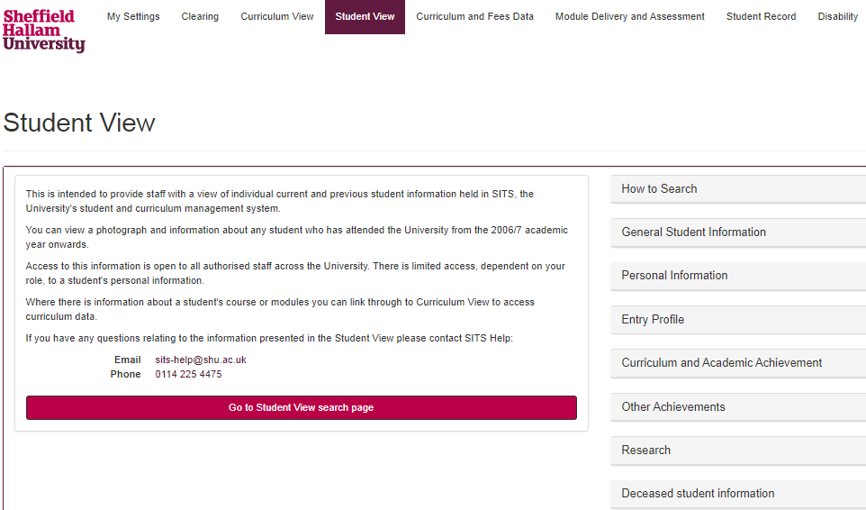

4. Enter a student name or number in to the Search Field and click Search;
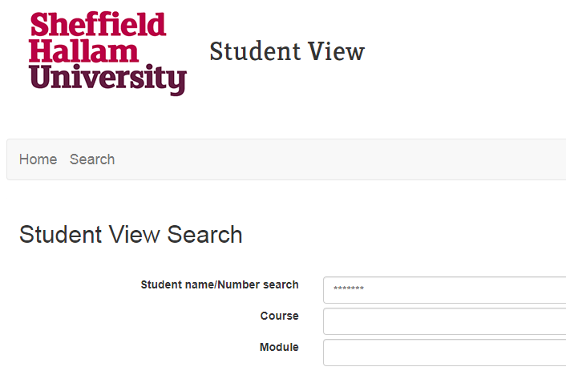
5. Select relevant student from results by clicking Details;
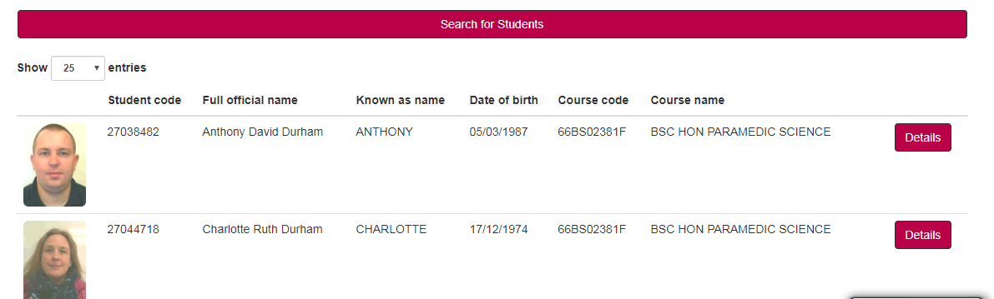
6. Scroll down to the bottom of the student page and you will see the student's Student Support Adviser and Academic Adviser (Employability Adviser will be added soon);
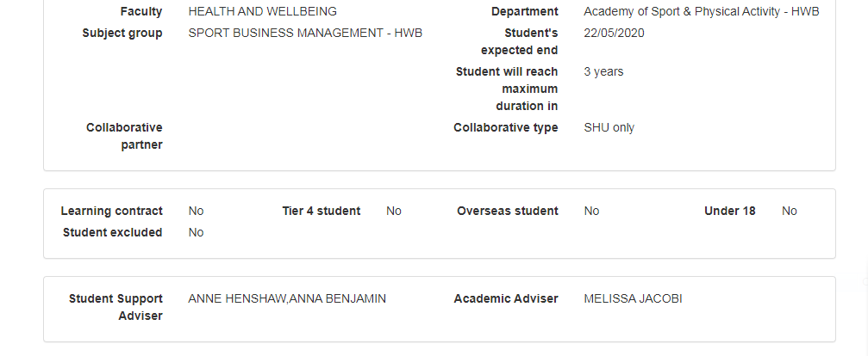

Please contact Melissa.Jacobi@shu.ac.uk in the first instance;
- If the Academic Adviser field is not visible, it means the allocation is not recorded in SITS - log the issue by sending the student number and course name;
- If there is a change to an adviser allocation - provide details of the change for updating.

