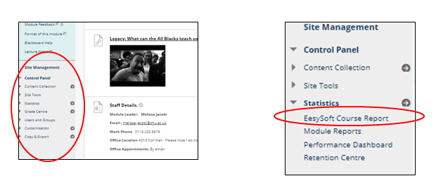

In a Module BB site, access Site Management, then under Statistics click EasySoft Course Report.
Provides some general access statistics for staff and overall usage patterns for the time period you have asked it to access.
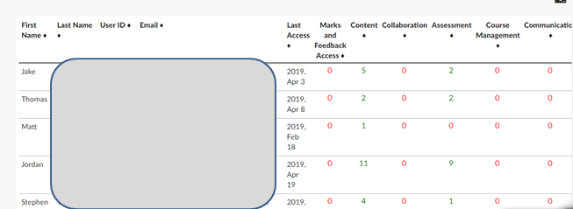
If you scroll down you'll also see how frequently students have accessed certain areas.

